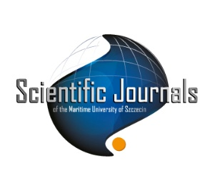

the Scientific Journals of the Maritime University of Szczecin

ul. Starzyńskiego 8, 70-506 Szczecin, Poland, phone (+48) 91 480 9616, fax (+48) 91 480 9723
https://scientific-journals.pm.szczecin.pl/ e-mail:journals@pm.szczecin.pl
PUBLISHING HOUSE OF THE MARITIME UNIVERSITY OF SZCZECIN

Dear Readers,

I am pleased to present the first of the quarterly issues for 2026 (No. 85), opening a new year for our publishing activity. This issue comprises six scientific papers, addressing current and diverse research problems, reflecting the interdisciplinary nature of contemporary studies in the fields of transport, engineering, and safety.

This issue includes contributions focused on, among others, the analysis of wear in rail vehicle components and methods for its reduction through the appropriate control of drive systems, as well as the application of advanced material technologies in the regeneration of marine engine components, with a particular emphasis on economic and operational benefits.

A significant part of this issue is devoted to safety and risk management. Such papers address the application of the Haddon matrix in risk analysis, as well as the identification and prioritization of physical risk factors in the shipboard working environment. This thematic scope is complemented by a study on seafarers’ health, proposing a modern approach to the detection of metabolic syndrome using digital tools and predictive methods.

This issue also presents a conceptual method for usability testing of graphical user interfaces for maritime autonomous surface ships, contributing to the ongoing development of advanced maritime technologies and autonomous systems.

This collection of papers highlights the current research directions and their practical implications, particularly in terms of efficiency, safety, and sustainable development.

I hope that this issue will be of interest to you and will serve as an inspiration for future research and academic discussion. I would like to thank the authors and reviewers for their valuable contributions and commitment to maintaining the high scientific quality of the journal.

Yours sincerely,

Editor-in-Chief
Paweł Prajzendanc, PhD Eng.

